Procedure to Check United Healthcare Claim Status
To check United healthcare claim status need to login to below URL.
URL : https://identity.onehealthcareid.com/app/index.html#/login
Below is the screenshot of the page, need to Enter the username and password, and click on Sign In or the page to be redirected to Verification of Identity code.
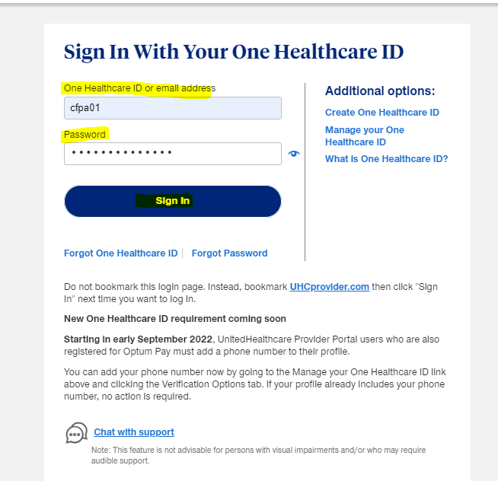
Once we get redirected to the Verify your Identity page, Need to select the Email to which we need to get the Verification code from the provided option and click next.
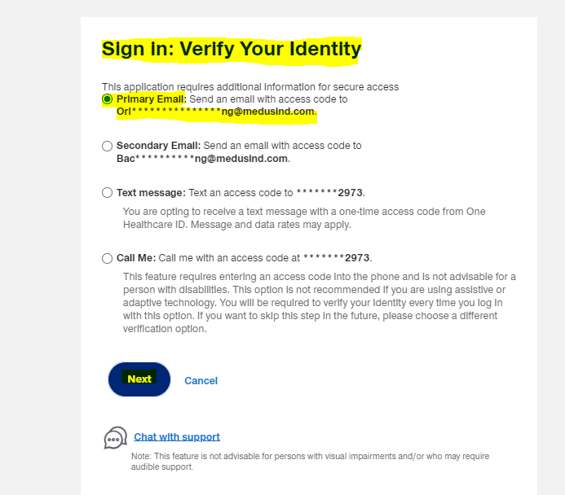
Once the Code is generated, the page will redirect to the below page to enter the Code. Once we enter the code, need to click the check box for Skip this step in the future, so that we need not enter the code for every login. Then Click on Next to Login to the portal.
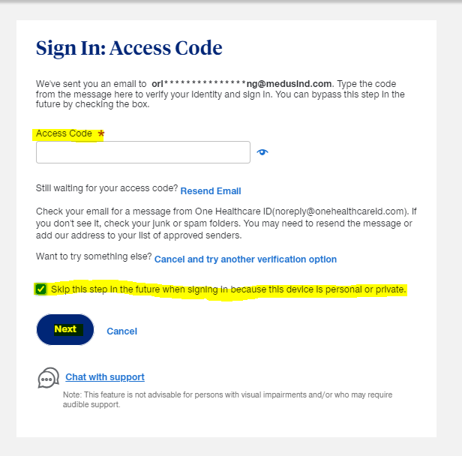
Once logged in click on the Claims & Payments to check the claim status.
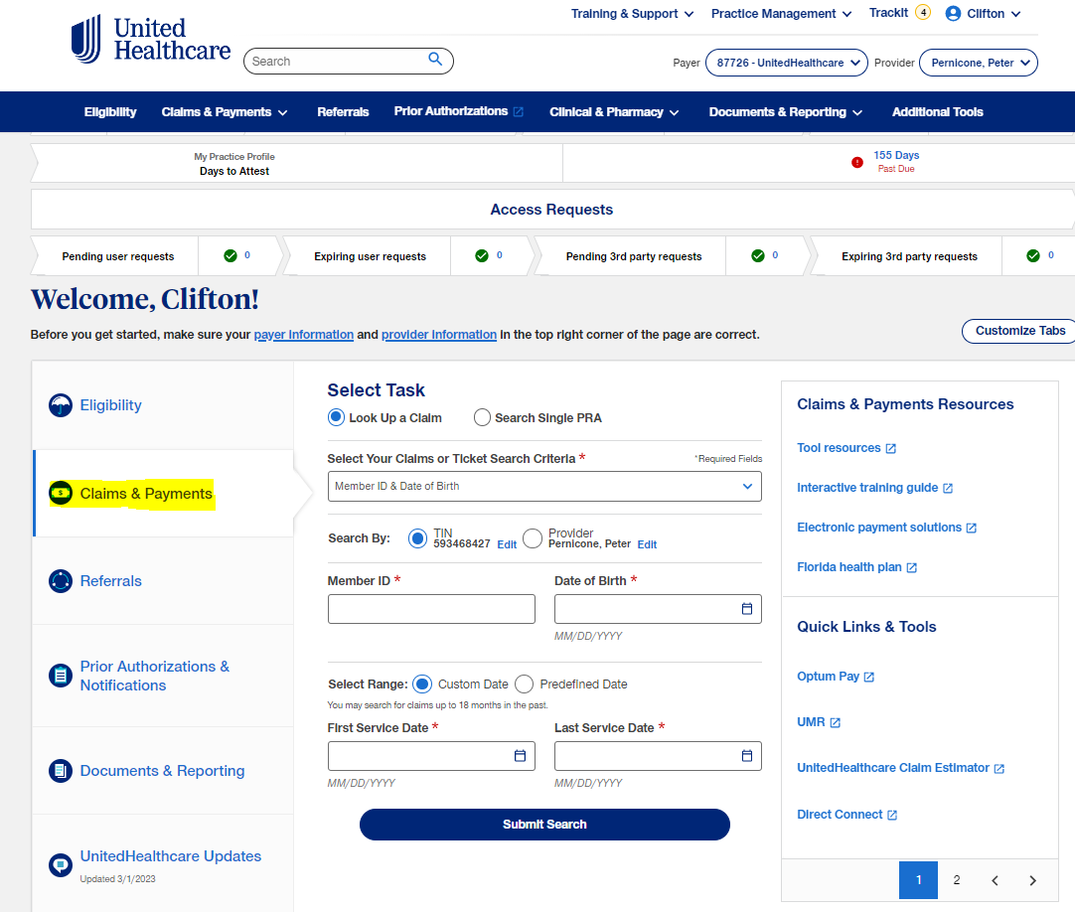

Now select the search criteria for the claim
- Member ID & Date of Birth
- Member ID & Name
- Member Name and Date of Birth
- Claim # or patient Account #
Then enter the data as per the criteria selected and enter the Date of service and submit search.
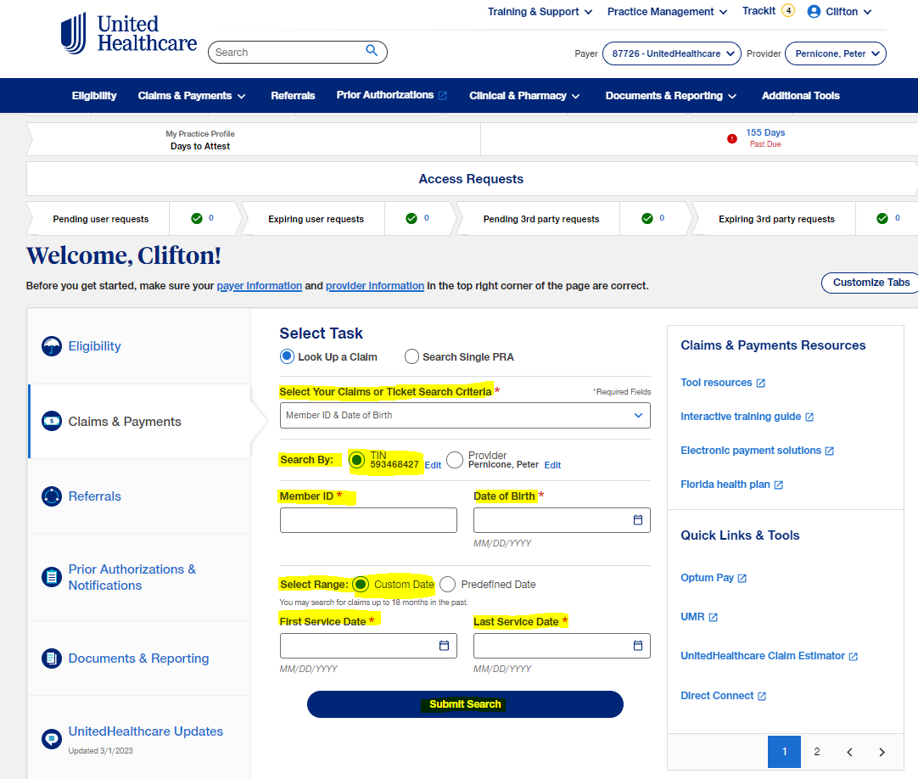
To get the patient details need to login to Medclarity.
Login to Medclarity - > Select “Orlando” in Enterprise -> Type the first word of the Entity name -> Click the Practice name from the Business Entity Search.
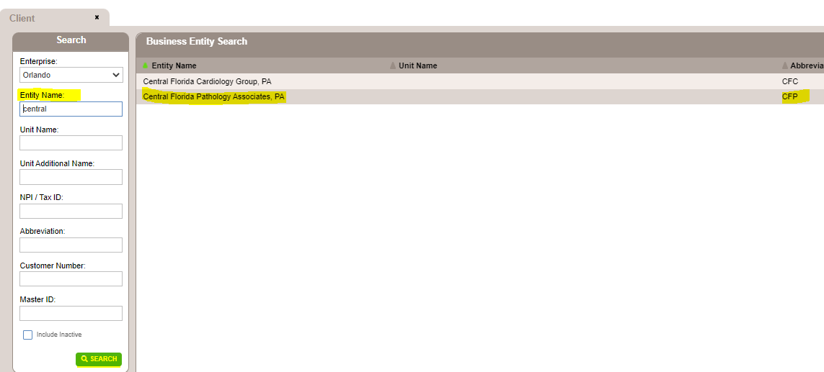
Once the practice opens, click the “Reimbursement” with the "$" Symbol
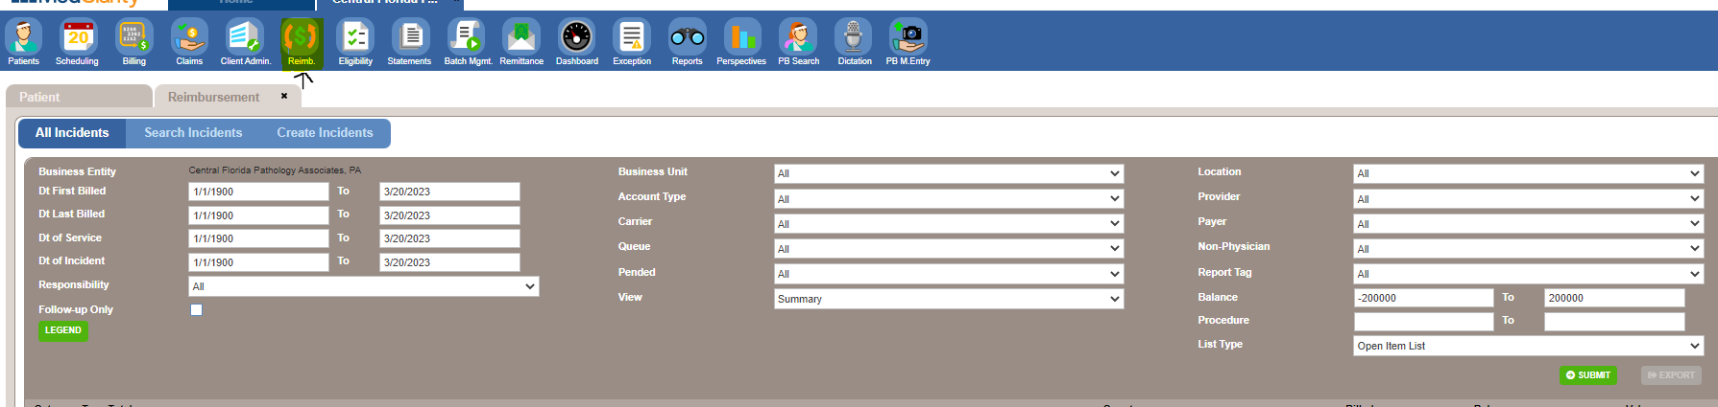
Then Click on dropdown in Queue and select Queue for No response claims.
Then Click the dropdown in the View tab and select “Details” and click on Submit to view the list of claims in the Queue.

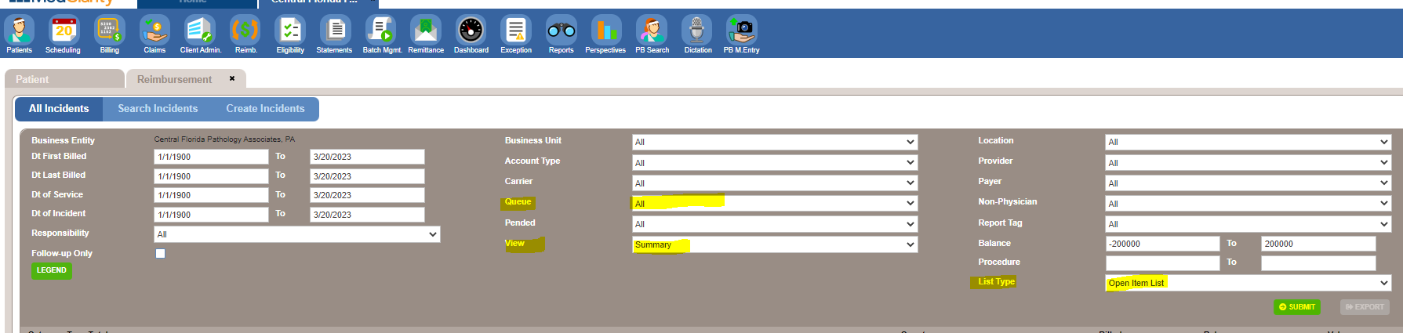
To find the claim, we can do "CTRL+F", then click the Claim ID, it will show you the CPT details billed in the claim.
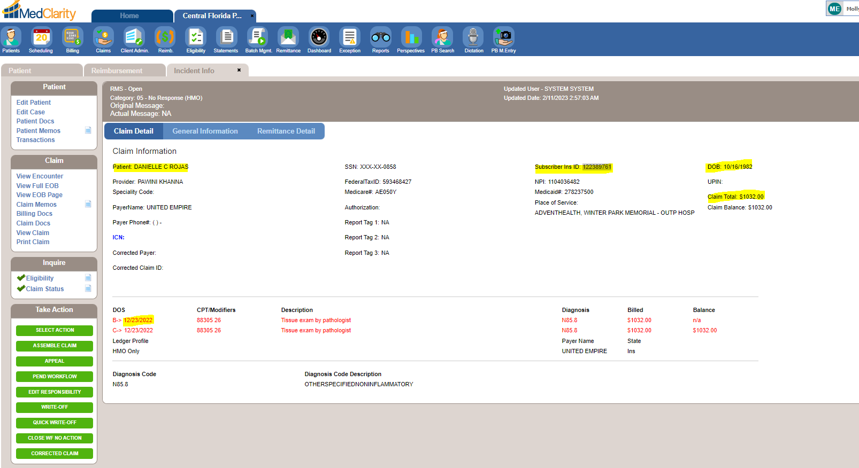
Now we have the patient information to check the claim status, enter the same in United healthcare portal.
Once all the Mandatory fields are entered, need to click on Search, which will pull the Claim status.
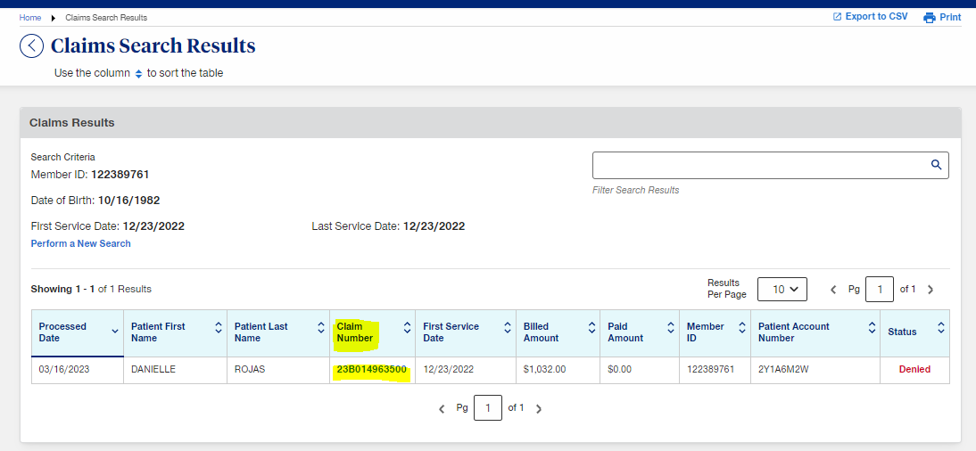
Now we have to click on Claim number to display the detailed claim status.
Once the detailed claim status in obtained scroll down for Detailed status of the claim.
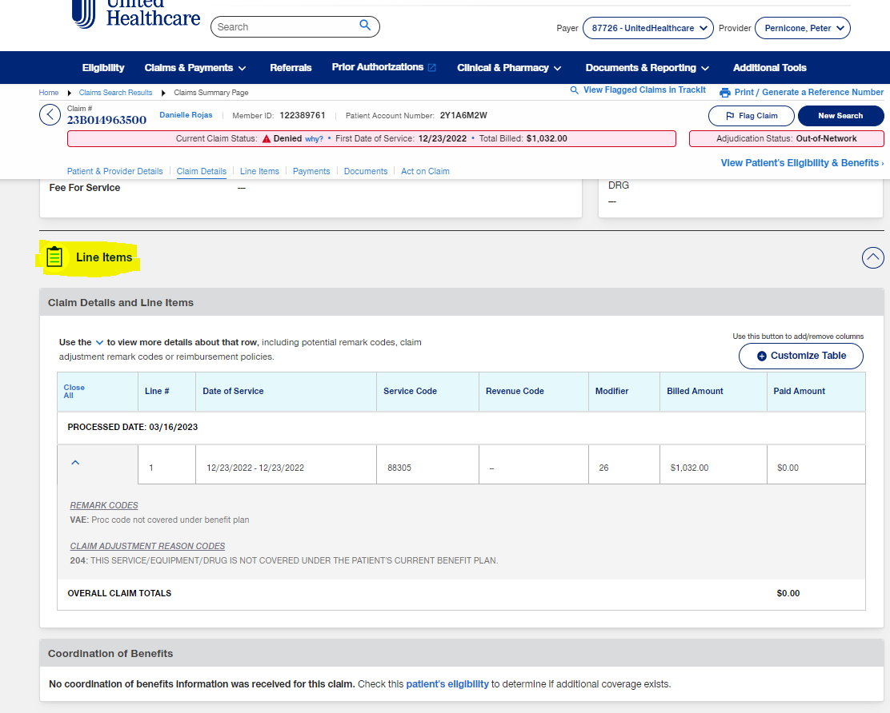
If we have to check patient Eligibility, need to click on Patient's Eligibility highlighted in Blue, this will provide the eligibility for the patient for the DOS on the claim.
If we want to download full EOB, need to click on Remittance Advice Document.
If we have any correction on the claim need to click on Submit Corrected Claim.
If we have to submit a reconsideration, need to click on Create Claim Reconsideration.
If we have to Appeal/dispute, need to click on File Appeal/Dispute.
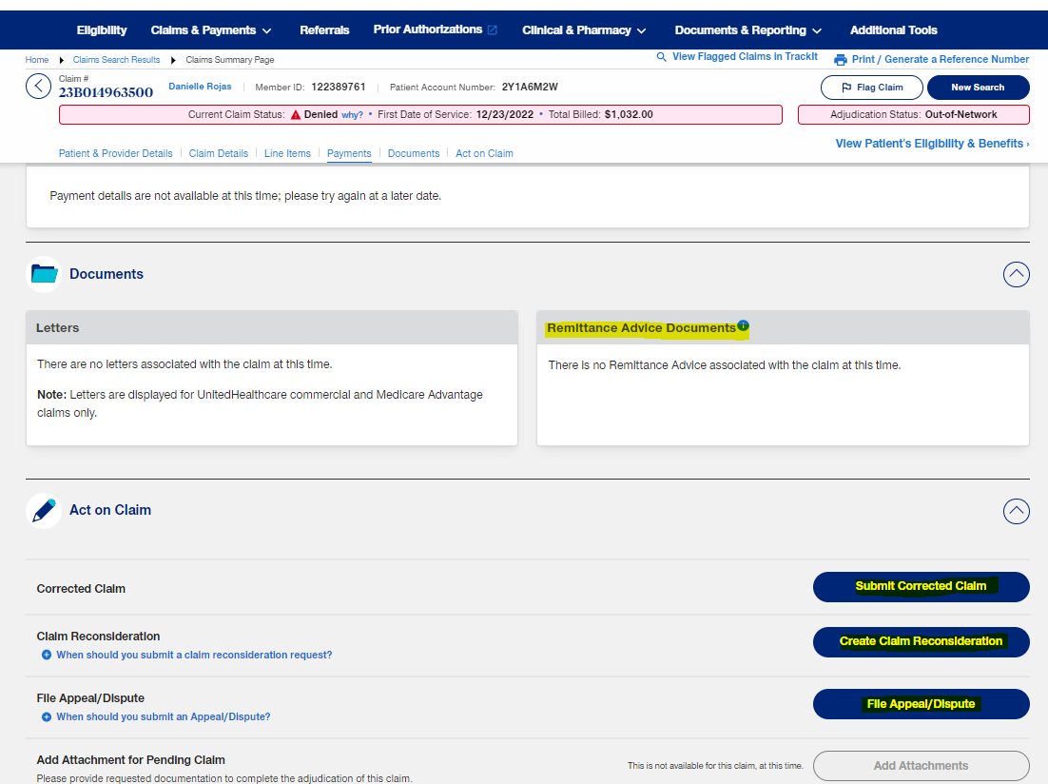
If we have to check patient Eligibility, need to click on Patient's Eligibility highlighted in Blue, this will provide the eligibility for the patient for the DOS on the claim.
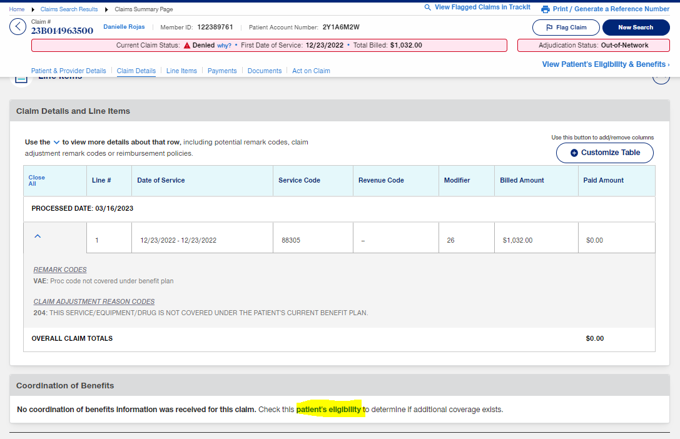
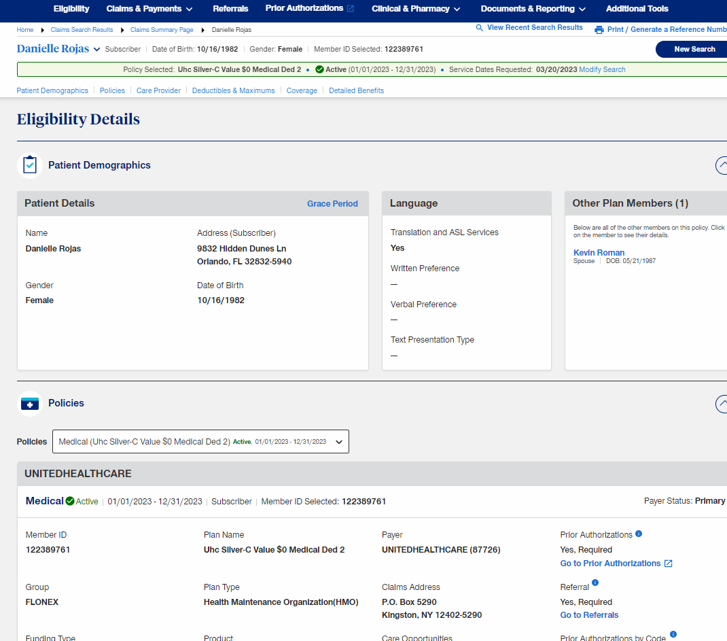
If we have to check Eligibility for Other DOS need to check manually by Clicking on the Eligibility Check under My Transaction.
Need to select the Service location (NPI) from the Dropdown, Enter patient's Medicare Number, Patient First Name or DOB, Last Name and Date of service.
Once all the details is entered click on Check eligibility to display detailed Eligibility status.

